**1. Overview**

The **AI Recommendation System** ingests text-based content (PDFs, CSVs, web pages), converts it into vector embeddings (using **Ollama**), and stores these embeddings in **ChromaDB**. Users can then search or chat with the system, which retrieves semantically similar content to generate contextually relevant recommendations or AI responses.

* **Current Phase**: **Proof of Concept (POC)**, running on a bare-metal environment with CPU-based embeddings (no GPU).
* **Future Goals**: Potentially deploy on-premise or to the cloud (AWS, Azure, GCP), possibly containerized (Docker/K8s), add authentication/roles, and improve scalability/performance.

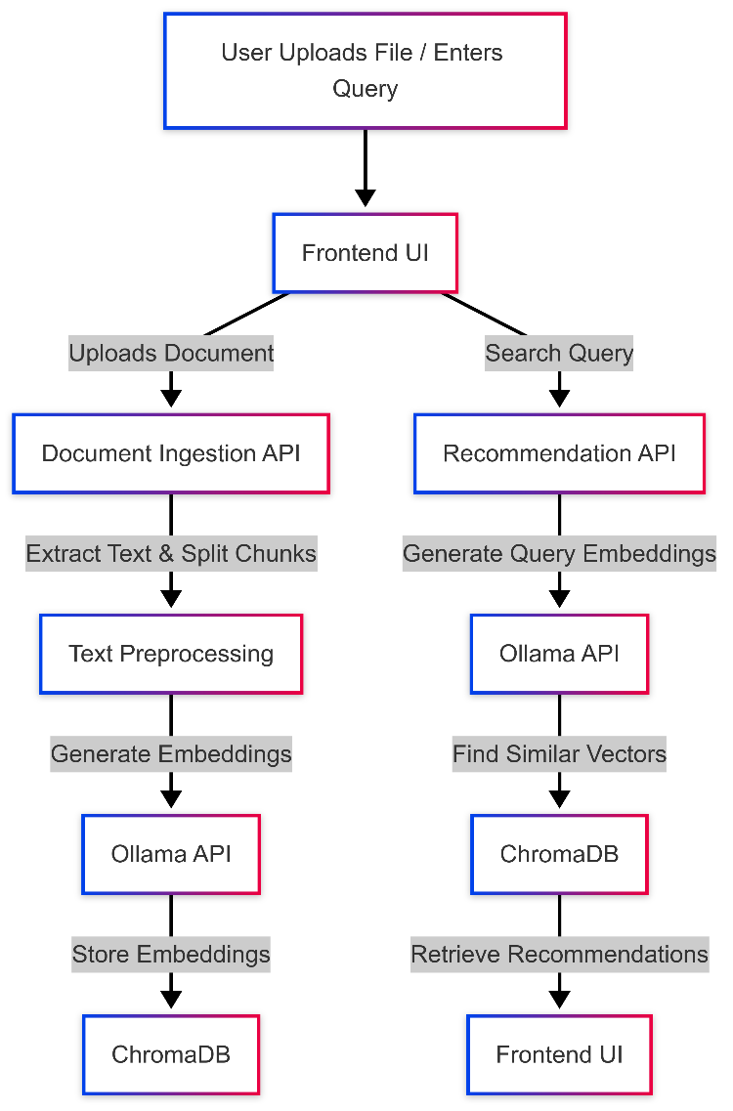**2. System Architecture**

**Chat with AI**

Mistral 7.2 AI model

mxbai-embed-large large-scale embedding model

**2.1 Frontend (Client)**

* **Technology**: HTML5, CSS3, JavaScript.
* **Purpose**:
  + Provides UI for uploading documents (PDF/CSV/URL), setting chunking parameters, and viewing recommendations.
  + Offers a Chat interface to interact with an AI assistant.
  + Maintains a **Report Builder** to preview and export PDF/CSV reports.
  + Contains **DB Maintenance** pages (list, delete, or clear documents).
* **Key Pages**:
  + **index.html**: Main UI for ingestion, search, chat, and report building.
  + **db_maintenance.html**: Provides admin-like controls (clear DB, remove duplicates, etc.).
  + **report_builder.html**: Lets users arrange and preview custom reports.

**2.2 Backend (Server)**

* **Technology**: **Flask** (Python).
* **Responsibilities**:
  1. **Ingestion** (/ingest):
     + Determines file type (PDF, CSV, or URL).
     + Calls the relevant ingestor (e.g., pdf_ingestor.py, csv_ingestor.py, web_ingestor.py) to extract and clean text.
     + Splits text into chunks (sentence-based by default, with optional size/overlap parameters).
     + Embeds each chunk via Ollama and stores the result in **ChromaDB** (with metadata).
  2. **Recommendations** (/recommend):
     + Receives a user query, embeds it (Ollama), and queries ChromaDB for similar content.
     + Returns top matches as JSON.
  3. **Chat** (/chat):
     + Similar to /recommend, but assembles a richer prompt (retrieved chunks + user query) to generate a cohesive AI response.
  4. **Database Maintenance** (/db_maintenance/...):
     + Admin endpoints for listing documents, deleting by ID, clearing the DB, checking ingestion status, etc.
  5. **Reporting** (/report, /report-preview, /report-export):
     + Aggregates data from the vector DB, generates PDFs/CSVs, and includes basic visualizations (matplotlib, word clouds).
* **Stateless**: No session-based authentication yet. All endpoints are open in the POC.

**2.3 Vector Database (ChromaDB)**

* **Purpose**: Stores vectors (embeddings) and associated metadata to enable fast similarity search.
* **Implementation**:
  + Persistent storage (typically DuckDB + Parquet).
  + Supports metadata fields: file_hash, filename, ingestion_timestamp, snippet, product_name, source, document_text, etc.
* **Scalability**:
  + Single-node, but can scale up (RAM/CPU) to handle thousands or millions of vectors.
  + Potential for approximate nearest neighbor indexing if performance is needed at scale.

**2.4 Ollama (Local Embedding & LLM Service)**

* **Role**: Generates high-dimensional embeddings for text, enabling semantic similarity. Also provides LLM responses for the chat endpoint.
* **Deployment**: Runs locally as a CPU-based service in this POC. GPU or cloud-based usage could be introduced later.

**3. Data Flow**

**3.1 Ingestion Flow**

1. **User Action**: Upload PDF/CSV or enter a URL in the frontend.
2. **Frontend** → /ingest (Flask):
   * Detects file type, calls relevant ingestor (e.g., pdf_ingestor.py using PyMuPDF + Tesseract if OCR needed).
   * Cleans text, splits into chunks (sentence-level).
   * Each chunk is embedded via **Ollama** and stored in **ChromaDB** along with metadata (timestamp, file_hash, etc.).
3. **All-or-Nothing**: If ingestion fails, it’s manually handled (no partial ingestion is stored).

**3.2 Recommendation & Chat Flow**

1. **User Query**: In the main UI, user enters text (search or chat).
2. **Frontend** → /recommend or /chat:
   * Flask calls **Ollama** to embed the query.
   * Searches **ChromaDB** for the most similar chunks.
   * For chat, constructs a prompt with the user query + top chunk context and calls Ollama for an AI response.
3. **Results**: The system returns JSON to the frontend, which displays relevant documents or a chat answer.

**3.3 Database Maintenance & Reporting**

* **DB Maintenance**: The user can open db_maintenance.html to list, delete, or clear documents.
* **Reporting**: The /report endpoints fetch aggregated data, generate PDFs/CSVs, and optionally include simple charts or word clouds.

**4. Deployment & Environment**

* **Current**:
  + Running on bare-metal with CPU-based embeddings.
  + No Docker/Kubernetes in place.
* **Future**:
  + Move to on-premise or cloud (AWS, Azure, GCP).
  + Containerize (Docker Compose, Kubernetes) for easier scaling:
    - Separate containers for Flask, Ollama, and possibly ChromaDB.
  + Scale horizontally (multiple Flask instances behind a load balancer) and/or vertically (larger machine for ChromaDB).

**5. Security & Authentication**

* **None in POC**: All endpoints are public.
* **Roadmap**:
  + Add user roles (admin vs. normal).
  + Implement JWT or session-based authentication.
  + Possibly enforce admin-only access to ingestion/maintenance endpoints.
* **Compliance**: No current HIPAA/GDPR constraints.

**6. Error Handling & Logging**

* **Logging**: Uses Python’s built-in logging; no external aggregator (e.g., ELK, Sentry).
* **OCR/Embedding Failures**:
  + If PyMuPDF or Tesseract fails to extract text, ingestion is halted.
  + If Ollama is down, also halts ingestion.
* **Manual Intervention**: As it’s a POC, any ingestion error is handled manually. Future expansions may include retry/queue systems.

**7. Reporting & Visualization**

* **Outputs**: PDF or CSV.
* **Visuals**: Basic placeholders (charts, word clouds) via matplotlib and wordcloud.
* **Scaling**: Limited features in the POC. Could expand to advanced dashboards or interactive visualizations in the future.

**8. Roadmap & Potential Enhancements**

1. **Authentication & Roles**: Implement security for ingestion/maintenance endpoints.
2. **Scalability**: Approximate nearest neighbor (ANN) search in ChromaDB, GPU-based embeddings, Docker/K8s for horizontal scaling.
3. **Automation**: Bulk/scheduled ingestion with background job queues (e.g., Celery, RQ) instead of manual single-file ingestion.
4. **Enhanced Reporting**: Interactive dashboards, advanced analytics, more output formats (HTML, PPTX, etc.).
5. **Metadata & Versioning**: Further refine metadata, add version control if files are re-uploaded with slight changes.
6. **Additional File Formats**: Possibly handle DOCX, PPT, or specialized formats.
7. **Multi-Language Support**: If needed, detect and handle multiple languages or add translation steps.
8. **Performance & Logging**: As the system grows, introduce detailed monitoring, alerts, and logs aggregation.

**9. Conclusion**

This **POC** demonstrates core functionality for an AI-driven Recommendation System:

* **Embeddings**: Ollama is used to generate semantic embeddings for text, stored in **ChromaDB**.
* **Queries & Chat**: The Flask backend retrieves relevant chunks from ChromaDB and optionally uses Ollama again for chat-style responses.
* **Frontend**: A straightforward HTML/JS UI allows users to ingest data, run queries, chat, maintain the DB, and generate basic reports.

While it’s not production-hardened (no authentication, minimal error handling, manual ingestion steps), the architecture is flexible. By adding scalability (Docker/K8s), robust security (JWT, role-based access), advanced logging/monitoring, and more sophisticated reporting, this system can evolve into a powerful platform for real-world AI-driven recommendations.

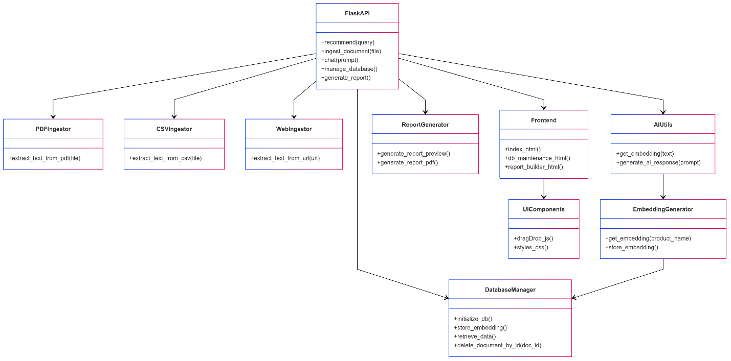

**AI Recommendation System – Comprehensive Overview**

**1. Purpose and Scope**

Your AI Recommendation System provides:

1. **Document Ingestion** – via PDF, CSV, or URL sources, with optional OCR if text extraction fails.
2. **Vector Embeddings** – using **Ollama** and potentially **Mistral** for local CPU-based embedding and generation.
3. **Storage** – in **ChromaDB** (with persistent storage in DuckDB/Parquet).
4. **Query & Chat** – similarity search with ChromaDB, returning matching chunks to the user or to the AI (e.g., Mistral) to generate responses.
5. **Reporting** – generating PDF/CSV outputs and basic data visualizations (bar, line, scatter, word cloud).
6. **Maintenance** – admin endpoints/pages for listing, deleting, or clearing database entries.

Although it’s still a POC, the code you have implements most of the fundamental capabilities: ingestion, search, chat, simple reporting, and a bare-bones UI.

**2. Main Technology Stack**

* **Python + Flask**: The primary server-side framework handling HTTP endpoints like /ingest, /recommend, /chat, etc.
* **ChromaDB**: Vector database library for storing embeddings and metadata.
* **Ollama** (with Mistral or other local LLM models):
  + **Embedding endpoint**: api/embeddings using the mxbai-embed-large model.
  + **Generation endpoint**: api/generate for LLM responses (Mistral by default).
* **PyMuPDF (fitz)** + **Tesseract**: For PDF parsing and OCR fallback if text is non-extractable.
* **Pandas**, **Matplotlib**, **WordCloud** (optional): For CSV handling, chart creation, and possible word cloud generation in reporting.
* **HTML/CSS/JavaScript** (Frontend):
  + **index.html** – Ingestion UI, recommendation search, chat interface.
  + **db_maintenance.html** – Tools for database administration.
  + **report_builder.html** – Interactive report building, preview, and export.

**3. Code Files and Their Roles**

Below is a breakdown of each of the 17 Python/HTML files and the key libraries or features they utilize. The filenames match what you have in your environment:

1. **db.py**
   * Creates a **PersistentClient** from ChromaDB and a **global_collection** (named "products").
   * Central point where other modules import this global collection.
2. **document_ingestion.py**
   * Contains a single function ingest_document(source_path, source_type) that dispatches to PDF, CSV, or web ingestion.
   * Uses chromadb.PersistentClient to get the "documents" collection.
   * Demonstrates adding placeholder embeddings ([0]*768) just as an example. (In practice, you use real embeddings from Ollama in your other code.)
3. **dynamic_chunker.py**
   * Contains dynamic_chunk_text(text, chunk_size, chunk_overlap) logic.
   * Uses **NLTK** (nltk.sent_tokenize) to split text by sentence boundaries, then applies chunk sizing and overlaps.
   * Provides a more “natural” chunking approach than purely splitting by character count.
4. **ingestion_manager.py**
   * Imports ingest_document from document_ingestion.py.
   * Illustrates example usage: ingesting example.pdf, example.csv, and a sample URL.
   * Simple script that loops over a list of doc configs.
5. **ai_utils.py**
   * Defines two main utility functions for working with **Ollama**:
     1. **get_embedding(text)** – Sends a POST request to OLLAMA_API_URL (embedding endpoint), expecting JSON with "embedding" field.
     2. **ollama_generate_response(prompt, context="")** – Calls OLLAMA_GENERATE_URL (generation endpoint) with the prompt and uses Mistral (by default) for language-model text responses.
   * Both handle networking, JSON parse, timeouts, and basic error logging.
6. **generate_embeddings.py**
   * A script that reads in products.csv, gets embeddings from Ollama, and stores them in the "products" collection in ChromaDB.
   * Demonstrates how to remove old data, compute new embeddings, and reinsert them with metadata.
7. **test_openai.py**
   * A quick test script for **OpenAI** API integration (using an openai.api_key).
   * Lists the available models to confirm the key is working.
   * Not heavily used in your main flow but included to test OpenAI’s endpoints.
8. **test_mistral.py**
   * A simple script that calls an installed local **Ollama** binary (ollama.exe) with the Mistral model to generate text (e.g., summarize AI benefits).
   * Demonstrates direct usage of Mistral from the command line, bypassing the Flask endpoints.
9. **reporting.py**
   * Houses logic for generating aggregated data from the vector DB, creating visualizations (matplotlib), and building HTML or PDF content.
   * Key functions:
     1. **aggregate_enriched_data(recommendation)** – Queries ChromaDB for top matches, aggregates metadata.
     2. **generate_visualization_from_metadata(...)** – Makes simple bar charts, etc.
     3. **generate_visualization_from_dataset(...)** – For user-supplied CSV data.
     4. **generate_report_preview** – Assembles HTML content with placeholders for blocks/charts.
     5. **generate_report_pdf** – Renders the final PDF using pdfkit.
   * Uses both **matplotlib** for charts and **WordCloud** in certain chart types.
10. **app.py**

* The **Flask** application. Includes routes:
  + **/ingest** – Processes file uploads or URL ingestion. Delegates to pdf_ingestor.py, csv_ingestor.py, or web_ingestor.py.
  + **/recommend** – Embeds the user’s query and searches ChromaDB for top matches.
  + **/chat** – Similar to recommend, but after retrieving chunks, it calls ollama_generate_response to produce a combined LLM answer.
  + **/product-summary** – Summarizes a selected product by name.
  + **/db_maintenance/<action>** – Clear DB, remove duplicates, list documents, etc.
  + **/report** + related – For building and exporting reports.
* References: ai_utils, db.py, utility.py, pdf_ingestor.py, csv_ingestor.py, web_ingestor.py, reporting.py.
* Manages chunking parameters (size, overlap, dynamic chunking flag), embedding calls, and metadata insertion into ChromaDB.
* Also sets up the HTML routes for index.html, report_builder.html, db_maintenance.html.

1. **utility.py**

* Provides a VectorDBUtility class, encapsulating common ChromaDB operations:
  + get_existing_ids(), delete_documents_by_filename(), remove_duplicates(), etc.
* Centralizes certain database manipulations instead of repeating them in app.py.

1. **report_builder.html**

* Frontend page for building a custom report.
* Allows adding “blocks” (CSV, images, etc.), specifying chart types, and previewing an HTML report.
* Integrates with /report-preview and /report-export endpoints in Flask.

1. **db_maintenance.html**

* A page that calls the admin-like endpoints (e.g., /db_maintenance/clear_database, etc.).
* Contains form fields for deleting by filename, ID, etc.

1. **index.html**

* The **main UI**:
  + **Ingestion**: File or URL upload, chunk size/overlap settings, “Use Dynamic Chunking” toggle.
  + **Recommendations**: A query box to get search-based product suggestions from /recommend.
  + **Chat**: A box to talk with the AI via /chat.
  + **Report Building**: Button to jump to the separate /report page.
* Also includes placeholders for debug info and internal logic for updating slider values, displaying results, etc.

1. **csv_ingestor.py**

* Uses pandas to read CSV content, merges rows into strings, then splits them into chunks using **LangChain’s** RecursiveCharacterTextSplitter.
* Returns a list of chunk dicts: {'text', 'snippet', 'product_name'}.

1. **pdf_ingestor.py**

* **PyMuPDF (fitz)** to read PDF pages. If text is not found, it calls Tesseract to OCR the page image.
* Cleans the extracted text, applies chunking (either dynamic_chunk_text or RecursiveCharacterTextSplitter), and returns the chunk array.
* Adds metadata like ingestion_timestamp and a file hash.

1. **web_ingestor.py**

* **Requests + BeautifulSoup** to fetch a URL and parse out text from HTML.
* Cleans text and splits it with the same chunking approach.
* Returns chunks, each with 'text', 'snippet', 'product_name'.

**4. AI/LLM Components**

* **Ollama**: Deployed locally, handles both embeddings (mxbai-embed-large) and generation (Mistral or other models).
* **Mistral**: Tested specifically in test_mistral.py, also used in ai_utils.ollama_generate_response() if the model is set to "mistral".
* **OpenAI**: A minimal test is present in test_openai.py. This shows how you might use OpenAI’s LLM endpoints, but it’s not the main path in your POC environment.

The system uses these calls:

* **Embeddings**: For each chunk, POST /api/embeddings → returns {"embedding": [float, float, ...]}
* **Chat Generation**: For user queries plus relevant chunks, POST /api/generate → returns a text response from Mistral or whichever local model is configured.

**5. How the Pieces Fit Together**

1. **Ingestion**:
   * app.py → /ingest → calls the relevant ingestor (pdf_ingestor, csv_ingestor, or web_ingestor).
   * Extracts text, chunks it (NLTK-based or LangChain-based), calls ai_utils.get_embedding(text) for each chunk, and stores in **ChromaDB** with metadata.
2. **Recommendations**:
   * app.py → /recommend → embed the user’s query → search top n_results in ChromaDB → filter by distance threshold → return recommended chunks as JSON.
3. **Chat**:
   * app.py → /chat → also embed the user’s message → retrieve top chunks from ChromaDB → build a combined prompt → call ollama_generate_response() → return the AI’s text reply.
4. **Reporting**:
   * report_builder.html → user arranges blocks, uploads CSV or images → calls /report-preview to see an HTML draft → optionally exports to PDF or CSV with /report-export.
5. **DB Maintenance**:
   * db_maintenance.html → calls the admin endpoints (/db_maintenance/...) → can list or remove documents, clear duplicates, check if a file was ingested, etc.

**6. External Libraries and System Requirements**

* **Python**: 3.x
* **Flask**: Web framework for serving your endpoints.
* **Chromadb**: For vector storage and retrieval (with DuckDB).
* **Ollama**: Must be running locally to handle embeddings and Mistral text generation.
* **PyMuPDF (fitz)**: For parsing PDFs.
* **pytesseract** + **Tesseract OCR**: For image-based text extraction if a PDF has no machine-readable text.
* **NLTK**: Sentence tokenization for dynamic chunking.
* **Pandas**: Handling CSV ingestion, also used in generate_embeddings.py.
* **Matplotlib** & **WordCloud**: For generating basic charts or word clouds in your reporting.
* **BeautifulSoup4** + **Requests**: For web ingestion.
* **pdfkit** (with **wkhtmltopdf** installed): For generating PDFs from HTML.
* **OpenAI** library (optional, only in test_openai.py).

Where the code references environment or local paths (e.g., Tesseract, wkhtmltopdf, Ollama) you must install or configure them in your environment for everything to work.

**7. Future Enhancements (as recognized in the code/comments)**

1. **Authentication & Roles** (currently wide open, no user login).
2. **Scaling**: Containerization (Docker/K8s), or additional hardware for large volumes.
3. **Monitoring**: Logging to external services, alerts if Ollama or Tesseract fail.
4. **ANN Index**: For extremely large data sets, use approximate nearest neighbor or GPU-based embeddings to speed up similarity.
5. **Multi-File & Bulk Ingestion**: Possibly hooking a queue or job system (Celery, RQ) for continuous ingestion.
6. **More File Types**: DOCX, PPT, specialized data, multi-language text.
7. **Advanced Visualizations**: Expand beyond static charts or single-line prompts.
8. **Versioning**: Handling reuploads or updated documents in a user-friendly manner.

**Conclusion**

In summary:

* You have a **Flask**-based application that orchestrates document ingestion (with chunking, embeddings), recommendation queries, chat responses, and a small reporting system.
* **ChromaDB** is your embedded vector database.
* **Ollama** (Mistral) provides local CPU-based embeddings and LLM text generation, tested by test_mistral.py and integrated deeply via ai_utils.py.
* The 17 files cover ingestion logic, AI utilities, an admin UI, a main UI, a dynamic chunker, a reporting module, plus small scripts for testing OpenAI or Mistral.

Everything is present in the codebase: from partial duplication checks, to snippet extraction, to sample HTML pages, to direct Tesseract-based OCR for PDFs. While still a proof-of-concept, the system is already quite comprehensive in terms of data ingestion, vector-based retrieval, and basic AI responses.

This fulfills your request for a thorough review of **all** the components (downloaded or built) and how they are used across the 17 files, ensuring we haven’t missed any piece of the puzzle.

Your output indicates that the "mistral:latest" model has the following specifications:

* **Architecture:** llama
* **Parameters:** 7.2 billion
* **Context Length:** 32,768 tokens
* **Embedding Length:** 4,096
* **Quantization:** Q4_0
* **License:** Apache License Version 2.0